Psychology 465 / Educational Psychology 405 Personality and Social Development

University of Illinois at Urbana-Champaign FALL 2015

**Examination #4 Stems**

1. The defining feature of Bronfenbrenner’s (1979) *exosystem* is that it:

* *Industry, mass media, social services, local politics, neighbors*
* *An exosystem refers to… settings that do not involve the developing person… but in which events occur that affect, or are affected by… the developing person*
* *State governments may make laws that ultimately affect a family’s living conditions and subsequently the individual*

2. In their examination of the combined impacts of the home and child care environment on children’s social and behavioral outcomes, Watamura et al. (2011) found:

* *Watamura and colleagues set out to explore development as a function of cumulative risk and mesosystem interactions*
* *No single risk factor is sufficient to cause lasting harm*
* *Necessary to study simultaneously the multiple contexts that influence children’s development*
* *During early childhood, two salient contexts are the home and child care*
* *Possible that they have independent effects*
* *Also possible that combinations of experiences produce different outcomes*
* *Cross-context influences help shape young children’s socio-emotional profiles:*
* *Associations existed for both mother and caregiver reported behaviors*
* *As expected, the double jeopardy group experienced the poorest outcomes*
* *Home quality and parenting matter:*
* *Regardless of quantity and quality of child care experienced*
* *Differing patterns for prosocial behaviors*
* *It could be that the benefits of high-quality child care for prosocial behaviors are carried over to the home environment and thus reflected in maternal ratings (i.e., compensatory care)*
* *In contrast, benefits of a high-quality home environment are most notable in the contexts of high-quality child care (i.e., double protection)*

3. Rodkin and Roisman (2010) determined which participants in the NICHD Study of Early Child Care were popular by asking:

* *Popularity assessed by teachers ranking children’s “popularity with the other same-sex children” in the classroom.*
* *All children in the classroom were ranked, converted into 0-1 proportion*
* *grades 3, 4, 5, 6 averaged*
* *criterion for being popular is top third (also top fifth)*

4. Which of the following implications for prevention can be deduced from Laursen et al. (2007)?

* *[F]riendship moderates the interplay between peer and adjustment difficulties. Among children without friends, higher levels of social isolation during first grade predicted subsequent increases in internalizing and externalizing problems during second grade, and higher levels of internalizing and externalizing problems during first grade predicted subsequent increases in social isolation during second grade. Among children with friends, there were no prospective links*

5. From the point of view of Haun and Tomasello (2011), conformity:

* *conformity, especially strong conformity, serves a crucially important function in the transmission of human culture by promoting quick and stable in-group uniformity*

6. The proportion of children who conformed in the speak/conflict conditions of the Haun and Tomasello (2011) research was:

* *Preschoolers “often conform to a unanimous majority of three peers in spite of better knowledge (strong conformity) out of social motivations mainly” (p. 7)*
* *Similar to adults levels on Asch paradigm*
* *“even at this early age，children are beginning to show the kind of conformist tendencies that are part of the foundation of human cultural diversity.”*
* *The current studies demonstrate that children as young as 4 years of age are subject to peer pressure, indicating sensitivity to peers as a primary social reference group already during the preschool years. They often conform to a unanimous majority of three peers in spite better knowledge (strong conformity) out of social motivations mainly. Preschoolers’ levels of conformity closely match those reported for adults (Asch, 1956). While they respond truthfully on the majority of trials, they conform to their peers in just over one third of trials in both experiments. Most strikingly, they adjust their level of conformity from trial to trial depending on the privacy of their response. This behavior is subject to different interpretations. On the liberal end, one could argue that children conform to manage the others’ evaluations of their public self. This kind of behavior, however, has been argued not to be strategically used (Aloise-* *Young, 1993) or even understood (Banerjee, 2002) by children before around 8 years of age. To be slightly more cautious, one might argue that children realize the potential conflict that might arise from standing alone against a majority based on past experience. They might also remember from past experience that the best way to avoid such conflicts is by saying what everybody is saying. In the future, even more diagnostic experiments will have to dissect the exact mechanisms behind early conformist behavior. In addition, in adults different characteristics of the situation, such as size of the majority, the relation of the participant to the members of the majority and difficulty of the task have been shown to affect conformist tendencies. Similar consequences in children would support our hypothesis that the early strong social conformity we report here is adult-like in structure.*
* *Young, 1993) or even understood (Banerjee, 2002*

7. The Laursen et al. (2007) study design consisted of (*hint: read carefully the methods section*):

* *Laursen et al. (2007) standardized the number of positive (social participation) and negative (social isolation) nominations…*
* *By gender*
* *Within classroom*
* *Participants were drawn from17 classes in 13 schools in two public school districts in Central Finland.*
* *Two waves*
* *Psychosocial adjustment was assessed in an interview with items adapted from the Johns Hopkins Depression Scale*
* *Internalizing problems*
* *Externalizing problems*
* *Social engagement*
* *A peer-nomination procedure assessed positive and negative dimensions of social engagement.*
* *For positive nominations, participants were instructed to identify an unrestricted number of classmates whom ‘‘you spend the most time with.’’*
* *For negative nominations, participants were instructed to identify an unrestricted number of classmates whom ‘‘you spend the least time with.’’*
* *Mutual friends were identified on the basis of reciprocal positive nominations*
* *For each participant, a summary score was calculated reflecting the number of positive nominations received and the number of negative nominations received*

8. Which of the following variables were ***NOT*** covariates (i.e., taken into account or statistically controlled) in Rodkin and Roisman (2010)?

* *Demographic covariates, child sex, child African American vs. not, maternal education, income-to-needs from 6 to 54 months*

9. Henry Stack Sullivan focused on interpersonal relationships between:

* *Countered Freud on parental influence and the lasting importance of early experience.*
* *Highlighted the importance of a ”chum” or a close friend*
* *Friendships can be a buffer, a promoter, a protector*
* *the other fellow takes on a perfectly novel relationship with the person concerned*

10. Which of the following best reflects the results of Laursen et al. (2007) study?

* *[F]riendship moderates the interplay between peer and adjustment difficulties. Among children without friends, higher levels of social isolation during first grade predicted subsequent increases in internalizing and externalizing problems during second grade, and higher levels of internalizing and externalizing problems during first grade predicted subsequent increases in social isolation during second grade. Among children with friends, there were no prospective links*
* 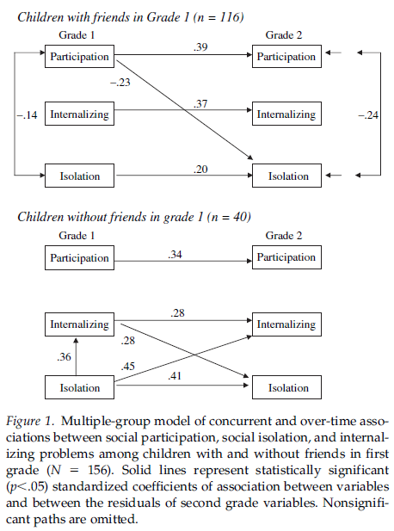
* 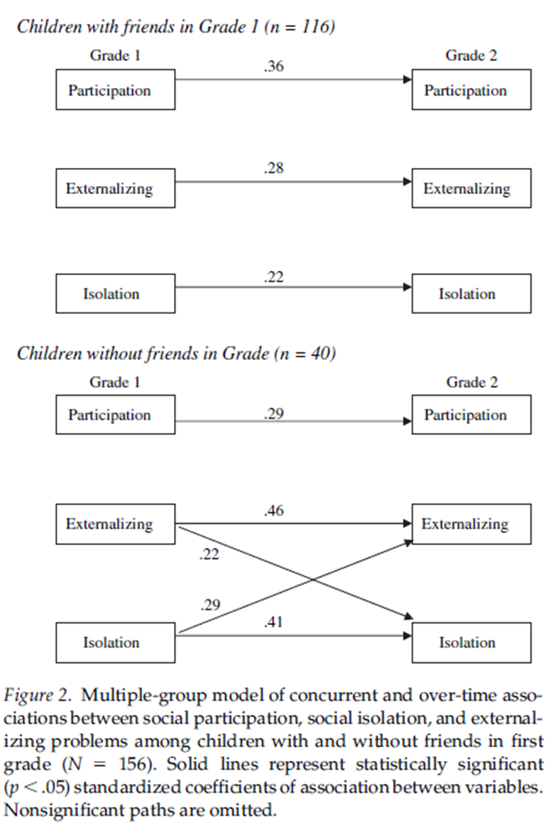

11. According to Rodkin and Roisman (2010), which of the following child care variables was associated with childhood aggression:

* *Early Child-Care Experiences Groups were examined on three measures of child care measured through 54 months: hours per week in nonmaternal child care (quantity), quality, and proportion of time in center-based care. Tough children spent significantly more time in nonmaternal child care than model, t(1018) = 3.12, p < .01, d = 0.58; nonpopular-nonaggressive, t(1018) = 3.30, p < .001, d = 0.62, and aggressive, t(1018) = 3.16, p < .01, d = 0.68, children. Tough children experienced significantly lower quality child care than model children, t(919) = 2.13, p < .05, d = 0.41, although the quality of their child care was comparable to nonpopular-nonaggressive children, t(919) = 1.39, p = .16, d = 0.26, and aggressive children, t(919) = 0.02, p = .99, d = 0.004. Tough children spent a marginally larger proportion of time in center-based care than model children, t(35) = 1.70, p = .098, d = 0.32, and nonpopular-nonaggressive children, t(34) = 1.98, p = .06, d = 0.39, but comparable time as aggressive children, t(45) = 1.24, p = .22, d = 0.26.*

12. Glenn Elder described a life-course approach to development in which he said that changes in an individual behavior or trait derive from which of the following:

* *Family as a microsystem linking societal change and individual development*
* *The life-stage principle: The influence of a historical event on the life depends on the stage at which individuals experience the event*
* *Psychologically and socioeconomically, boys in the younger Berkeley cohort fared worse: “The causal link between economic deprivation in the 1930s and adolescent behavior included a pattern of socioeconomic instability with its distorting influence on family life-- the emotional strain produced by resource exhaustion, loss of an effective, nurturant father, and marital discord*

13. Research has suggested that positive teacher-child relationships do which of the following to support children’s social-emotional development:

* *Teacher as a “friend”:*
* *Genes-aggression-victimization are all linked (rGE) but good a teacher-child relationship can attenuate (GxE) these links*
* *High-quality student-teacher relationships are one specific aspect of the school/classroom that have been shown to support positive socio-emotional and behavioral development.*
* *High quality relationships are marked by high levels of closeness and low levels of conflict*
* *Research has demonstrated the benefits of positive student-teacher relationships for a range of cognitive, social, and behavioral outcomes*
* *Compared with the children in the strong teacher-child relationship group, children in the strong-worsening, poor-improving, and poor worsening groups were significantly more likely to be in the moderate-low, moderate, and high externalizing groups.*
* *There were no such associations for internalizing behaviors, suggesting that the teacher-child relationship may not be as important for internalizing behaviors*
* *The effects of early internalizing behaviors on later internalizing behavior trajectories differed by student-teacher relationship quality.*
* *Children with high levels of early internalizing behaviors who were in the strong-worsening, poor-improving, and poor-worsening groups had higher levels of internalizing behaviors across elementary school*

14. O’Connor and colleagues (2011) argued there is a need to examine individual changes in the quality of the teacher-child relationship because:

* *Research has demonstrated the benefits of positive student-teacher relationships for a range of cognitive, social, and behavioral outcomes*
* *The teacher-child relationship may also be an important determinant of change in behavior problems during the elementary school years. For example, in a study of children in kindergarten and first grade, relationships marked by high levels of conflict were associated with a decrease in children's prosocial behavior and an increase in children's aggressive behavior over time (Birch & Ladd, 1998). In another study, high levels of conflict and low levels of closeness in the kindergarten teacher-child relationship were associated with rapid increases in externalizing behavior problems from kindergarten through third grade (Silver et al., 2005).*
* *Our understanding of teacher-child relationships and behavior problems, however, is limited as relatively little is known regarding the nature and course of teacher-child relationships during elementary school (Baker, 2006). It would be expected, however, that teacher-child relationships would evidence predictable variation across the elementary school period due to changes in children's physical, social, emotional, and cognitive development, as well as changes in the classroom environment. More specifically, the caregiving aspect of teacher-child relationships may decrease as children gain language skills, self-care competencies, and self-control (Baker, 2006). Additionally, the overall quality of the relationship may decrease in the elementary school years as children's relationships with peers become more central and as children spend less time with teachers. Changes in relationship quality may have consequences for children's socio-emotional and behavioral development. More specifically, an increase in relationship quality would be expected to support children's socio-emotional and behavioral development*
* *Research indicates that children's relationships with teachers are, indeed, dynamic and change in quality over time, particularly when considering year-to-year variations in children's relationships with different teachers (Lynch & Cicchetti, 1992; Midgley, Eccles, & Feldlaufer, 199D. Results from studies using variable-centered techniques suggest a decline in the quality of children's relationships with teachers across the elementary school years (Jerome, Hamre, & Pianta, 2008; O'Connor, in press; O'Connor & McCartney, 2007; Pianta & Stuhlman, 2004). However, these studies did not identify normative patterns of change, evidenced by the majority of children, over the entire course of elementary school. Research on parent-child relationships indicates normative change in relationship quality, as well as patterns of change indicative of problems in the relationship, during the elementary school years (see Bradley, Corwyn, Burchinal, McAdoo, & Coll, 2001; Collins, Harris, & Susman, 1995). Deviations from normative patterns of change in parent-child relationships are risk factors for children's socioemotional and behavioral development. Normative patterns of change, as well as patterns reflective of problematic relationships, would also be expected in the teacher-child relationship during this period. Identifying trajectories of change experienced by most children and those that are atypical and suggest dysfunction in the relationship is important for efforts aimed at sustaining children's socio-emotional adjustment through developmentally appropriate, supportive teacher-child relationships.*

15. Results from the O’Connor et al. (2011) study suggest that compared with children with strong teacher-child relationships over time, children who experience declines or children who experience poor-quality relationships early but slight increases over time were more likely to exhibit which of the following outcomes:

* *Compared with the children in the strong teacher-child relationship group, children in the strong-worsening, poor-improving, and poor worsening groups were significantly more likely to be in the moderate-low, moderate, and high externalizing groups.*
* *The effects of early internalizing behaviors on later internalizing behavior trajectories differed by student-teacher relationship quality.*
* *Children with high levels of early internalizing behaviors who were in the strong-worsening, poor-improving, and poor-worsening groups had higher levels of internalizing behaviors across elementary school*

16. Goodman et al. (2005) explored which of the following contexts in their examination of adolescent stress:

* *Goodman et al. (2005) explored the effects of SES and race/ethnicity on stress among adolescents*
* *Goodman et al. (2005) hypothesized …*
* *SES and race/ethnicity would independently predict stress across the full social (dis)advantage spectrum*
* *Race/ethnicity would independently predict stress among high SES teens while SES would independently predict stress among white teens*
* *Social disadvantage predicted higher levels of stress regardless of whether disadvantage is defined by SES or race/ethnicity*
* *In the full sample, lower SES (parental education) and being black predicted more stress*
* *Among the socially disadvantaged subgroup, neither race/ethnicity nor SES (parental education) predicted adolescent stress*
* *Among the socially advantaged subgroup, both race/ethnicity and SES (parental education) predicted adolescent stress*
* *Health disparities may be greatest among the socially advantaged*
* *SES and race/ethnicity themselves may not explain persistent health disparities; instead the challenges that exist in the broader social context may help explain these disparities*

17. Jencks and Mayer (1990) offered a set of models for understanding *how* an individual’s neighborhood might impact their social and personality development including which of the following:

* *Neighborhood institutional resources affect development through police presence and access to stimulating learning environments.*
* *Collective socialization models suggest neighborhoods affect children through community social organization.*
* *Contagion (epidemic) models suggest that negative behavior in neighbors and peers influences the behaviors others.*
* *Competition models suggest that neighbors and peers compete for scarce resources.*
* *Relative deprivation models suggest that neighborhoods influence development through individuals evaluation of their own circumstances relative to neighbors and peers.*

18. Which if the following statements about the development of social and personality traits is **FALSE:**

* *Early social behavior and personality traits derive from the individual (e.g., genetics, temperament, sex, race/ethnicity, temperament) and his/her immediate environment (e.g., early attachment relationships, parents, siblings, child care, etc.).*
* *As we age and our spheres of influence extend beyond the home, social behavior and personality traits are influenced both directly and indirectly by our broader contexts, including peers, schools, neighborhoods, local, state, and federal policies, etc.*
* *Perhaps most importantly, our behavior and personality emerges as a result of a set of complex interactions between us and our environments as well as between our various environments.*
* *Although there is evidence of stability in many social and personality traits, there is also considerable change.*
* *Genes matter but do not explain everything.*
* *Social and personality development is complex. To understand who we are and how we came to be requires a careful examination of the individual and a thorough consideration of the many interacting contexts he/she experiences across the lifespan*

19. Social isolation has been considered an index of exclusion while social participation reflects which of the following:

* *Social Participation*
* *Reflects the number of positive social engagement nominations a child receives; can be considered an index of inclusion*

20. Social conformity is best described by which of the following:

* *Social conformity reflects a social “pressure” to change one’s behavior or beliefs in order to fit in with the group*
* *Normative conformity*
* *Informational conformity*
* *conformity, especially strong conformity, serves a crucially important function in the transmission of human culture by promoting quick and stable in-group unifor*mity

21. According to Rubin et al. (1998) and the classic sociometric view, popular children are:

* *Popular children are skilled at initiating and maintaining qualitatively positive relationships [and] are also viewed as cooperative, friendly, sociable, and sensitive by peers, teachers, and observers. Popular children… can engage in some forms of assertive behavior, but they rarely engage in behaviors that are likely to interfere with the actions and goals of others*

22. According to the Erath and Tu (2013) article, peer coping is comprised of voluntary engagement and which of the following:

* *Sought to explore the independent and interactive effects of voluntary and involuntary responses to peer stress on social competence across the transition to middle school*
* *Results highlight the importance of considering physiological involuntary responses to peer stress in combination with voluntary responses to stress*

23. Watamura et al. (2011) argued that high-quality home environments could compensate for the negative effects of poor quality child care environments, offering which of the following as evidence for this:

* *As hypothesized, mothers who were characterized by low-quality HOME scores and low maternal sensitivity portrayed their children as having more internalizing and externalizing behavior problems and displaying less prosocial behavior than children in homes and child-care programs in the middle of the quality distribution (the reference group) when their children were also in low-quality child care (the Double Jeopardy niche). Their ratings of behavior problems did not, however, differ from those for the reference group when the children were in high-quality child care (the compensatory care group). This pattern of findings remained significant when extensive controls were included. The within-niche comparisons confirmed the disadvantages faced by children in the Double Jeopardy niche. These children had higher levels of mother-reported behavior problems than children in any of the other niches. In effect, children were reported by their mothers to have poorer social emotional outcomes when they experienced conditions of double jeopardy, but not when high-quality child care created conditions of compensatory care. Even mothers observed to provide lower quality care to their children at home rated their children as having more problems compared to mothers of children in the reference group, thus suggesting that they were decidedly not ‘‘normalizing’’ their children’s behavior*

24. Findings from Erath and Tu (2013) suggest that children’s social competence in stressful peer situations derive from which of the following:

* Expected that lower attentional engagement with the environment and higher inhibition/anxiety would be associated with more disengaged coping strategies.
* Also expected that disengaged coping responses would amplify the association between disengaged physiological responses (i.e., lower RSAR) and social competence while engaged coping responses would attenuate this association.
* Results highlight the importance of considering physiological involuntary responses to peer stress in combination with voluntary responses to stress.

25. The halo effect is best described as an emotional bias in which our impression of a person influences how we think or feel about other aspects of his/her character.

* The Halo Effect reflects a cognitive bias in which our overall impression of someone (or something) influences our feelings about that person’s (or objects) characteristics, skills, or properties
* Derives from theories of confirmation bias where positive feelings in one domain lead to positive feelings about more ambiguous or neutral traits